**Case Study: Grafana Dashboard for JMeter Performance Monitoring**

Configuring JMeter to send performance metrics to Influx DB.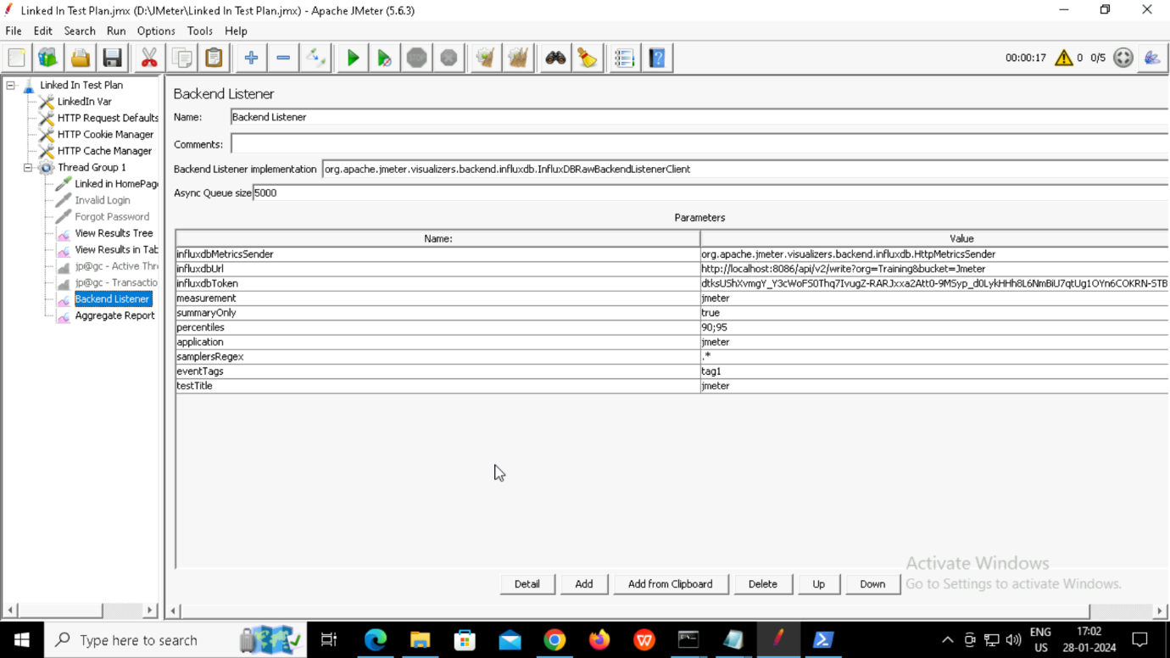

Setting up Grafana and adding Influx DB as a data source:

Configuring panel to display the desired metric using Influx DB queries.

